**Press release**  
*Specialist press*

**Kautex Maschinenbau appoints a new head of Global IT**

**As Head of Global IT, the IT specialist Robert Kubotsch is taking on overall responsibility for information technology at Kautex Maschinenbau. With this appointment, the global leader in extrusion blow molding machines has filled another key position to steer and support its process of change. Robert Kubotsch will harmonize the existing IT systems and optimize them for cooperation between the global Kautex team, customers and partners. Isolated solutions which have been used to date will be replaced with a uniform IT structure at all locations, and the availability of IT services and infrastructure at crucial points will be improved.**

Robert Kubotsch previously worked for an international plant and machinery manufacturer. In this role he was responsible for the maintenance and further development of IT at various locations. His experience of various projects across different sectors has given him a keen understanding of the business processes involved in running a machinery manufacturing enterprise, and its ever-expanding IT requirements.

Kautex Maschinenbau has been involved in a process of strategic realignment and restructuring for over two years. The company is bringing about harmonized processes and standards in line with the BeOne motto, as well as placing even greater emphasis on customer focus in all business areas. The production solutions are becoming more intelligent, modular, and flexible, and the aim is primarily to generate added value for customers.

These changes are accompanied by increasing digitalization in communication, production, and service. Data management, communication systems and comprehensive remote services place high demands in terms of the efficiency, standardization and global availability of IT. Kautex announced enhanced investment in this area some time ago. Robert Kubotsch and his team will now put the philosophy into action.

CEO Thomas Hartkämper has great hopes for his new colleague: “We are delighted to be able to welcome an experienced IT specialist for our global Kautex team in Robert Kubotsch. He is very process oriented and he has demonstrated what may be possible in the future. The huge investment in IT is an additional element for sustainable implementation of our new vision - BeOne Global Kautex Team.

Robert Kubotsch is looking enthusiastically at the pending projects in the Kautex team. “IT is the backbone for changes at Kautex. It is not just a matter of providing optimal support for processes; it is also about anticipating developments. Setting the right course is an extremely challenging task. I am looking forward to playing an active role in shaping the transition at Kautex while establishing a high degree of service quality throughout the group.”  
  
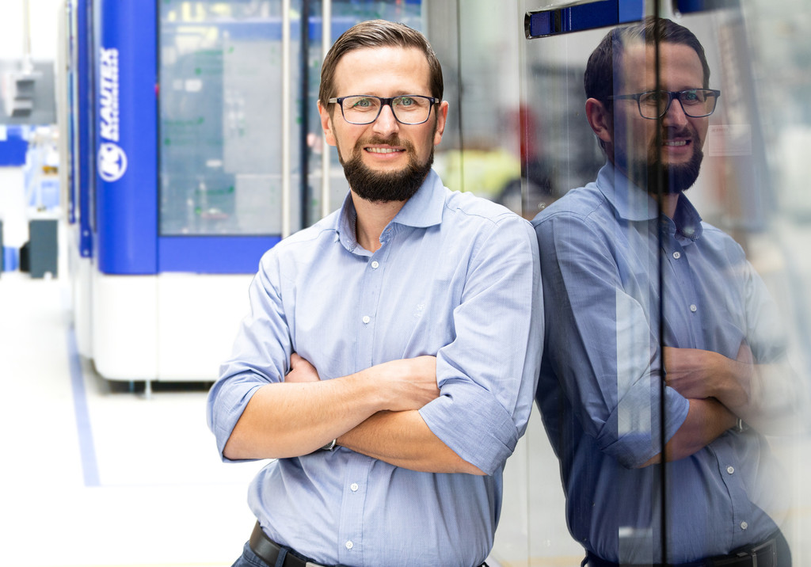

Robert Kubotsch

**About Kautex Maschinenbau**

Kautex Maschinenbau develops intelligent production solutions for the production of plastic containers. The company has shaped the plastics sector for 85 years with advanced extrusion blow molding machines. It works together with customers and partners to create added value for sustainable, economical production of extrusion blow molding articles of the highest quality.

A worldwide clientèle from a wide range of industrial branches puts its trust in the know-how of a brand which has represented great reliability, durability, and economic benefits for many decades.

As global market leader, the company employs around 550 people. The main production locations are in Germany and China. With more than 150 people employed in the fields of sales and service on all continents, the company is close to its customers in all locations with a unique service package.  
  
**Contact**

Christian Kirchbaumer  
Head of Marketing Communications

Kautex Maschinenbau GmbH  
Kautexstr. 54  
53229 Bonn

T +49 228 489370

christian.kirchbaumer@kautex-group.com